**DAILY ONLINE ACTIVITIES SUMMARY**

|  |  |  |  |  |  |  |  |
| --- | --- | --- | --- | --- | --- | --- | --- |
| **Date:** | **3/06/2020** | | | | **Name:** | **Vandana E V** | |
| **Sem& Sec** | **8th. A** | | | | **USN:** | **4AL15CS103** | |
| **Online Test Summary** | | | | | | | |
| **Subject** | | **-** | | | | | |
| **Max. Marks** | | **-** | | **Score** | | **-** | |
| **Certification Course Summary** | | | | | | | |
| **Course** | **Introduction to Hadoop** | | | | | | |
| **Certificate Provider** | | | **Great Learning Academy** | **Duration** | | | **4.5hrs** |
| **Coding Challenges** | | | | | | | |
| **Problem Statement:**  **1)To print the pattern of the following form containing the numbers**  **Sample Input 0**  **2**  **Sample Output 0**  **2 2 2**  **2 1 2**  **2 2 2** | | | | | | | |
| **Status: Executed** | | | | | | | |
| **Uploaded the report in Github** | | | | **Yes** | | | |
| **If yes Repository name** | | | | **Vandana** | | | |
| **Uploaded the report in slack** | | | | **Yes** | | | |

Certification Course Details:

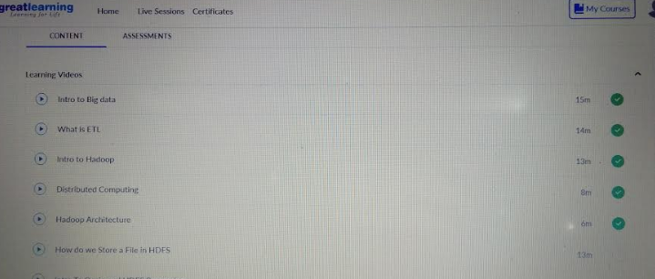

Coding Challenges Details:

**#include<stdio.h>**

**intmain()**

**{**

**intn;**

**scanf("%d",&n);**

**intlen=n*2-1;**

**for(inti=0;i<len;i++){**

**for(intj=0;j<len;j++){**

**intmin=i<j?i:j;**

**min=min<len-i?min:len-i-1;**

**min=min<len-j-1?min:len-j-1;**

**printf("%d",n-min);**

**}**

**printf("\n");**

**}**

**return0;**

**}**

|  |
| --- |
|  |
|  |
|  |
|  |
|  |
|  |
|  |
|  |
|  |
|  |
|  |
|  |
|  |